City of black diamond

BUSINESS Gambling Tax form

P.O. Box 599 - 24301 Roberts Drive

Black Diamond, WA 98010

Phone: 360.851.4500 – Fax: 360.851.4501

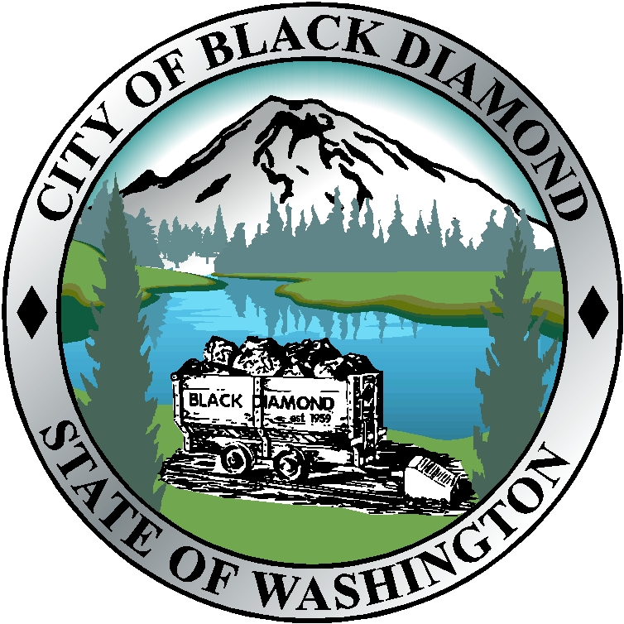

Business Name City Business Lic.# ______
Address_________________________________________________________________
Street or P.O. Box City State Zip
Quarter Year State Gambling License #
Sign and return this copy with your payment
See Ordinance number 618.
Gambling Activity | Gross Amount | Less Amount Awarded as Prizes | Net Amount | Tax Rate | Quarterly Tax Due
Bingo |  |  |  | 5%
Raffles |  |  |  | 5%
Amusement Games |  |  |  | 2%
Pull Tabs |  |  |  | 10%
Punch boards |  |  |  | 10%
Social Card Games |  | N/A | N/A | 20%
TOTAL | - | - | - | -
Exemptions, please list and explain:

PENALTIES: As set forth in City of Black Diamond Municipal Code.

I/we hereby certify under the penalties of perjury that the sum above shown is the amount of tax for which I am/we are liable for the quarterly period above shown under and computed according to the provisions of Municipal Code. I/we further certify that the information herein given and the amount of tax liability herein are full and true and I/we know the same to be true.

License Holder Title Date

************************************************************************************************
FOR CITY USE ONLY

Amount Paid Date Received T.R. # Clerk

