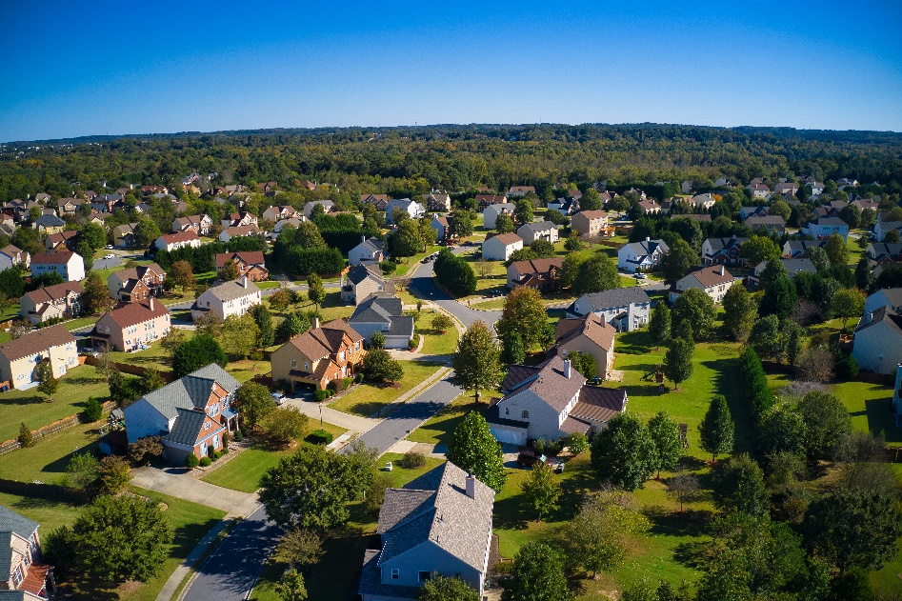

Is a Tree Removal permit required?
As Spring approaches and you are making plans for your landscaping, you may be considering tree removal. Tree removal is regulated under the City’s Tree Preservation Code in BDMC Chapter 19.30
Why does the City regulate the removal of trees?
Pursuant to BDMC 19.30.010 Intent -
The city recognizes the importance of trees for the benefits they provide to property values and to the environment. Trees stabilize soil and control water pollution, conserve energy, reduce storm water runoff, improve air quality, provide habitat to and protect wildlife, improve the appearance of the community, provide buffering and screening, provide shade and wind protection, conserve water supplies, and preserve the forested character of the Pacific Northwest that citizen's value. Preserving trees in large quantities also contributes to a reduction in global warming.
The objectives of this chapter include reducing tree loss during construction and development; reducing indiscriminate removal and destruction of trees; mitigating tree loss by requiring replacement of trees; and protecting significant and heritage trees.
When is a permit required to remove a tree?
A tree removal permit is required for the removal of significant trees. Some species of trees are exempt from requiring a permit and in some cases, you may apply for a tree removal exemption. Please call your friendly staff at Community Development at 360-851-4447, visit us in office, or send us an email at permits@blackdiamondwa.gov to determine if a tree removal permit is required for your project. Please visit the BDMC for further details about tree removal found in Chapter 19.30.
Please visit our checklists for more information.
Tree Removal Permit Checklist
Tree Removal Exemption Checklist

